Website content

Home Page

**Overview**

Australia has one of the highest rates of food allergies in the world. Nuts and dairy allergies top the chart with increase in cases amongst young children living in Victoria.

It’s not only your Child. Don’t Blame them or their genetics.

Want to know where you stand?

Take Quiz

It’s not only your Child. Don’t blame them or their genetics.

Want to know where do you stand?

Take Quiz



What is Food Allergy?

An adverse reaction by the immunse system towards a certain type of food is termed as Food Allergy. For many sensitive children, minute allergic reaction can be frightening and life threatning. In extreme cases it can lead to immediate hospitilization or even death.

**The Solution**

**5 nuts foceses on…….**

**The Problem**

**Australia has one of the highest rates of food allergies in the world. Nuts and Dairy allergies top the chart with increase in cases amongst young children living in Victoria.**

# A picture containing text, clipart Description automatically generatedAllergy Page

Nuts&Dairy Home Allergy Quiz Resources

Fact 🡪

**Check for Symptoms? 🡨 Click this button**

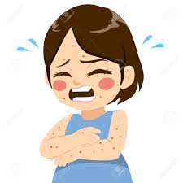 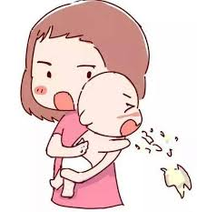 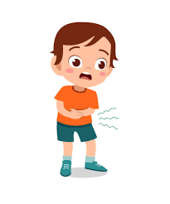

Breathing difficult Excessive Itching Nausea & Vomitting Stomach pain Mouth Tingling

What is Food Allergy?

An adverse reaction by the immunse system towards a certain type of food is termed as Food Allergy. For many sensitive children, minute allergic reaction can be frightening and life threatning in extreme cases which leads to immediate hospitilization.

Did you know? The most common triggers of food allergy are **egg, cows’ milk (dairy), peanut, tree nuts, sesame, soy, wheat, fish and other seafood.**But almost any food can cause an allergic reaction, including fruits.

Nuts&Dairy Home Allergy Quiz Resources

Are you a new parent?

Check the top 8 most allergic foods 🡪

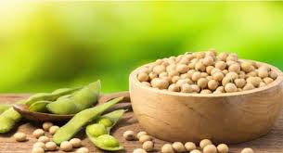

**Check for Symptoms? 🡨 Click this button**

Breathing difficult Excessive Itching Nausea & Vomitting Stomach pain Mouth Tingling

What is Food Allergy?

An adverse reaction by the immunse system towards a certain type of food is termed as Food Allergy. For many sensitive children, minute allergic reaction can be frightening and life threatning in extreme cases which leads to immediate hospitilization.

Overview

Australia has one of the highest rates of food allergies in the world. Accordingly nuts and dairy allergies top the chart with increase in cases amongst youn children living in Victoria.

It’s not only your Child. Don’t Blame them or their genetics.

# Allergy Page

**Causes**

Adverse Reaction Triggering the below mentioned symptoms

Food Intolerance towards specific type of food

Genetic issues

Environmental Impact by moving to a different country

Its everywhere in the world. Every child is different

Want to check few facts ?

**Graph explanation**

In Australia 3.2Million people reported that they avoid food due to food allergies and intoloerance.

Nuts and dairy allergies itself consume over 11% of the allergies.

Lack of knowledge among busy and working parents leads to paying improper attention for their young children. This severity causes immediate hospitalization and even deaths in extreme cases.

Whilst children avoid food due to allergies, many people also avoid food due to cultural reaons.

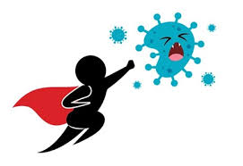

# Resources Page

Sometimes Fear is Overwhelming. Relax!! Its Okay

We are here for you.

Links to articles🡪 Maximum 3